Planting Ceremony for the Coronation of King Charles III
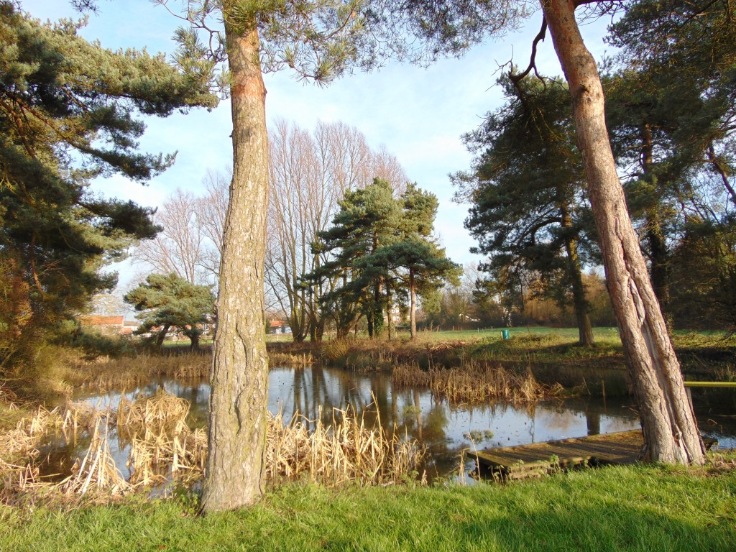

- Welcome ………….............................................. Lesley Dennon
- Poetry ……………..…………………………………………... Year 4
- Speech and planting the tree ………………………….. John Ljundell
- Oak Tree poem ................................................ Year 5
- Oak Tree Prayers ……......................................... Year 4
- Blessing of the tree …………................................. Jean Huby
- Introduce and show the plaque ……………………….. Lesley Dennon
- National Anthem……………………………………………… All
- Final words…………………………………………………….. Lesley Dennon
- Tea and biscuits at Cawood Primary………………….. All

National Anthem
God save our gracious King!
Long live our noble King!
God save the King!
Send him victorious,
Happy and glorious,
Long to reign over us,
God save the King.

