Working to reduce flood risk in your area

|  |  |
| --- | --- |
|  | December 2022 |

Improvements to Cawood flood risk management assets

This document aims to provide you and your community with details of the work we are focussing on in and around Cawood during the next few years.

Foreshore Monitoring

The Environment Agency has commissioned a monitoring survey of Cawood foreshore, which will be used to monitor the amount of movement occurring in an area between the church and the bridge, highlighted in orange in the map below. The data will provide us with evidence to decide on how we maintain the foreshore and flood risk management assets in the future.



The work involved installation of stainless-steel monitoring points in the crest of the floodwall (by way of drilling and fixing), and multiple ground markers at intervals between the floodwall and the river’s edge. These markers will be monitored for movement using a manual height measuring tool.

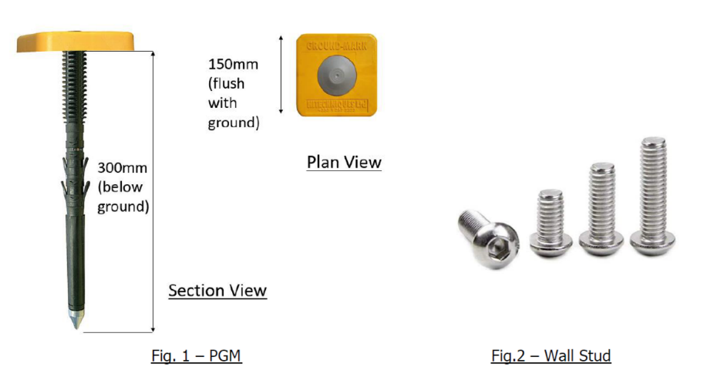

We have commissioned the survey contractor, Tetra Tech Limited to carry out 5 recordings over the first year which started in September.

We aim to take further measurements in November, February, March, and June. Access will be required to each of the gardens for a short period of time during the day only (direct communication with necessary residents in place).

Transfer of Bishop Dyke Pumping Station from Yorkshire Water to the Environment Agency

Work and discussions are continuing between Yorkshire Water and ourselves to facilitate the transfer of the Pump Station to our ownership. The map below shows the location of the pumping station and associated assets. Facilitating this transfer requires documentation to be provided, surveys to be undertaken and knowledge to be shared. Both organisations are cooperating to allow this.

The Environment Agency are finalising a project for delivery in 2023 to improve the reliability of the pumping station which is fundamental to completing the transfer of the asset.

Yorkshire Water have committed to continue to attend the asset to reset pumps, provide access and share expertise whilst the Environment Agency completes preparations to take over the asset.

All previously actioned contingency arrangements are now being carried out by the EA as and when required to ensure the system is working as required. We have worked with the Parish Council to install a drop bollard that will make deployment of the contingency easier. We have subsequently tested the contingency arrangements.

As such you may continue to see both organisations working in the vicinity as the facility is transferred and brought up to the required standard.



Who can I contact for more information?

If you would like further information on this project, please get in touch using the contact details below:

[YORKS.AP.SUNOW@environment-agency.gov.uk](mailto:YORKS.AP.SUNOW@environment-agency.gov.uk)

Post - National Customer Contact Centre PO Box 544 Rotherham S60 1BY United Kingdom

Email - enquiries@environment-agency.gov.uk Telephone - 03708 506 506 (Monday to Friday, 8am-6pm)

Incident Hotline - 0800 80 70 60 - to report flooding, blockages, pollution, unusual changes in flow of water, collapsed or badly damaged defences (24-hour service).