Bishop Dike

History & Background February 2022

Bishop Dike is an artificial channel which runs from Sherburn-in-Elmet to the banks of the River Ouse at Cawood, with a long history of use from supply of water to the local mills through to a method of transporting local materials. In more modern times this has been used more directly as a way of managing land/surface water drainage.
When water levels in Bishop Dike are high, excess flow is transferred into the Selby Dam catchment via the overflow structures upstream of Cawood (locally known as the bathtubs) in order to prevent water backing up further along Bishop Dike. The radial sluice gate upstream of Cawood has a purely flood defence function and is designed to prevent flooding in Cawood. In summary, when Bishop Dike Pumping Station is unable to discharge sufficient water, the resulting backwater effect causes an increase in water levels upstream of the pumping station. Elevated levels in Bishop Dike, downstream of the radial gate, cause the gate to close which prevents more water flowing into Cawood.
Once sufficient water can be discharged into the Ouse to drop the water level in Cawood the gate opens allowing the watercourse to flow into Cawood again.
Once the gate closes the overflow structures are designed to maintain the water levels in Bishop Dike. To do this excess water flows into the Selby Dam system which is able to discharge a greater volume to the Ouse.

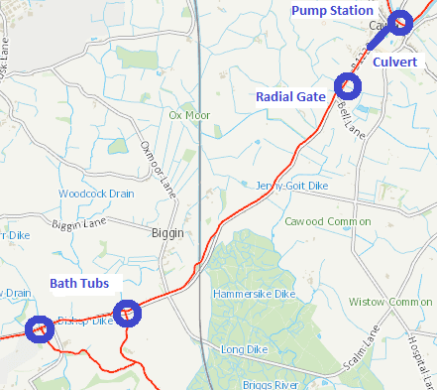

Work to date
Following the winter flooding of 2020/21 we conducted thorough inspections and reviews as per the following
- The, 3rd party owned, culverted section of the dike in Cawood from Castle Garth to the Pumping Station was inspected using CCTV on 3rd June 2021.
  - No blockages were observed, and water was flowing without restriction.
  - The majority of the culvert also appeared to be in an acceptable structural condition.
  - The culvert will remain in our inspection programme going forward.
- A review of the, Environment Agency owned, Radial Gates reported no underlying issues regarding their condition and operation.
  - The gate is inspected quarterly
- Planned Preventative Maintenance occurs every 6 months including greasing of all the moving parts.
- This financial year we are undertaking a project to maintain the first bathtub (the one closest to Sherburn in Elmet).
  - We have cleared, inspected, and repaired the structure.
  - A further phase of repair work is scheduled for completion before the end of March 2022.
- These measures and repairs mean that our assets are operating as expected, with the watercourse discharging under gravity whenever possible and pumping when conditions in the Ouse prevent a gravity discharge.
- The EA funded Internal Drainage Board annual weed control was completed summer 2021.

Ongoing / current work
Work and discussions are ongoing between Yorkshire Water and ourselves to facilitate the transfer of the Pump Station to our ownership.
- Facilitating this transfer requires documentation to be provided, surveys to be undertaken and knowledge to be shared. Both organisations are cooperating to allow this.
- The Environment Agency is currently developing a project to improve the reliability of the pumping station which is fundamental to completing the transfer of the asset. This is likely to take 3 to 6 months to develop/mobilise and is a precursor for formal transfer.
- Yorkshire Water have committed to continue to attend the asset to reset pumps, provide access and share expertise whilst the Environment Agency completes preparations to take over the asset.
All previously actioned contingency arrangements are now being carried out by the EA as and when required to ensure the system is working as required. We are working with the Parish Council to agree some minor works that will make deployment of the contingency easier.
- As such you may continue to see both organisations working in the vicinity as the facility is transferred and brought up to the required standard.
- Continual review and inspections of all EA assets
- We are also working in partnership with The Yorkshire Dales Rivers Trust who have been leading the Rivers in Elmet Project. The project has been predominantly funded by the Agency and aims to address sediment, nutrient loading, and habitat modifications in five adjoining waterbodies (Collingham Beck, Thorner Beck, Cock Beck, Mill Dike and Bishop Dike) in the lower Wharfe and lower Ouse catchments. The project is now in its second phase of delivery (April 2020- March 2023). For more information please visit. Rivers In Elmet Project - Yorkshire Dales Rivers Trust (ydrt.org.uk)

