The Selby Treasures Exhibition is now virtual and available to view online.
Explore the special collection of personal memories and historic objects from Selby people and learn about Selby artefacts that were loaned from other museum and local archaeological finds.
Many people came along to the Selby Treasure Exhibition that was hosted in Selby Abbey earlier this year. It was the final event in the Selby 950 programme, celebrating 950 years since the founding of Selby Abbey and featured a specially assembled collection of personal memories and historic objects from Selby people.
During a series of Pop Up Museum events, the people of Selby were asked “if you had to choose one special object for a Museum of Selby what would you choose and why?” The Exhibition showcased some of the answers that were received.
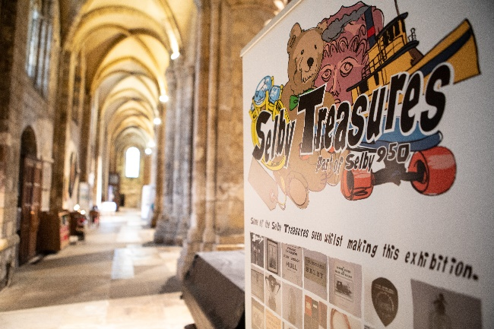
From family history to national events, each object was selected for the story it told. The connection between the object and the storyteller was captured by artist Simon Grennan, through his portraits of people both past and present holding their special objects. Sitting alongside the objects lent by local people were a selection of objects linked to Selby on loan from regional museums.
The exhibition attracted in the region of 2,000 visitors and inspired many people to bring in their objects to share. A small selection of these objects have been added to the virtual exhibition and the rest have been recorded for future reference.
Lead executive member with responsibility for housing, health and culture, Cllr Chris Pearson, commented, “At a time when day trips and heritage visits are restricted, it is great that, thanks to National Lottery Heritage Funding, we’ve been able to take some of the exhibition material from Selby Treasures and make it accessible for everyone. Making the exhibition virtual means we can discover some of Selby’s treasures from the comfort of our own home.”
He added “2019 was a great year for Selby as the town came together to celebrate 950 years since the founding of Selby Abbey. Stories were told; the heritage of the town and its people were brought to life - and the virtual exhibition is a fantastic and fitting legacy.”
Visit the website for the Selby Treasures Online Exhibition.
This project has been made possible thanks to money raised by National Lottery players, as the National Lottery Heritage Fund has awarded funding to Selby District Council to deliver a programme of arts and heritage events celebrating 950 years since the founding of Selby Abbey.
Notes to Editors
The National Lottery Heritage Fund
Using money raised by the National Lottery, we Inspire, lead and resource the UK’s heritage to create positive and lasting change for people and communities, now and in the future. www.heritagefund.org.uk. Follow @HeritageFundUK on Twitter, Facebook and Instagram and use #NationalLotteryHeritageFund

Communications

