The way recycling is collected in the Selby district is changing with a move to a new wheelie bin system.
Starting next week there will be a ten week delivery programme to enable 80,000 new bins to be delivered to 40,000 properties across the Selby district, before the new collections begin at the end of March/beginning of April. The new blue wheelie bin is for glass, cans and plastic and the new brown one is for paper and cardboard.
There is no change to the type of recycling collected by Selby District Council, just a change to the containers the recycling goes in. The new wheelie bins offer more room for residents to recycle more of their waste.
Collections will still take place every two weeks. Some collection days might change due to a review of the collection rounds to make sure they’re as efficient as possible. An information pack and full collection calendar will be delivered to every home in the district.
Leader of the Council, Cllr Mark Crane explained, “The existing system of separate recycling boxes was introduced because at the time there were no nearby recycling sorting plants that we could take this material straight to.
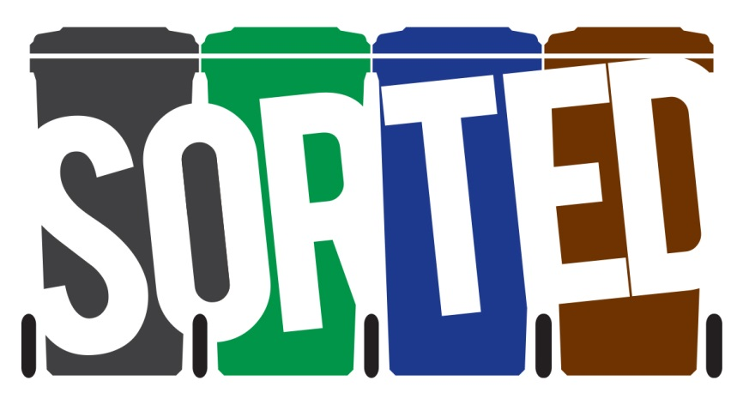
“We carried out a detailed review of the service, which included a major consultation that more than 6,700 residents took part in. We want to make sure our service is in line with the Government’s long-term waste strategy – keeping paper and card separate to other recyclable material – which is why two new bins are needed. The new wheelie bin system will allow us to collect high quality material and will be easier for householders to use.
“Moving to wheelie bins will give nearly 50% more room to recycle and we hope that our residents will embrace the opportunity to boost their recycling.”
There are no changes to refuse and garden waste collections. More information about the new service is available here - www.selby.gov.uk/welcome-our-recycling-and-waste-service.

Communications

