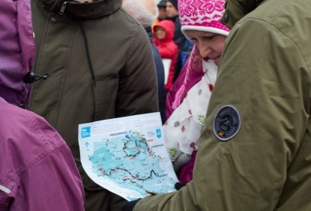
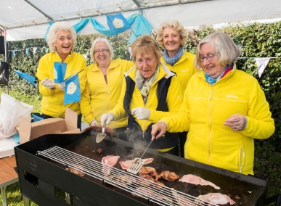
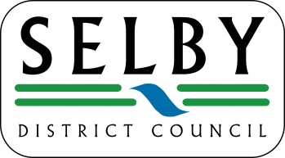
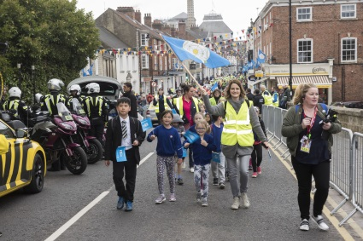
Getting Ready to Celebrate Selby District’s Big Year
2019 is a big year for the Selby District as we host major cycling events in our historic market towns and witness races pass through some of our fantastic countryside and villages.

Make the most of this opportunity and celebrate - it’s a fantastic time to come together, get involved and showcase all that our district has to offer.

Ways to get your Parishes involved and to help
- Encourage residents, businesses, communities and school groups to celebrate
- Organise get togethers and community events – let us know about events in your area
- Dress the cycle routes – bikes, flowers, bunting, flags
- Spring clean – clear away litter, keep the streets, paths and pavements clear
- Decorate houses – flags, bikes, bunting, flowers
- Blue, yellow and rainbow colours everywhere!
SPECTATE…CHEER…ENJOY!
Key Dates
2nd May 2019 : Tour de Yorkshire Stage 1 Men’s Race throughout the District and finishing in Selby
21st September 2019 : Yorkshire 2019 Para-Cycling International. Road races through the District, with a rolling start in Tadcaster
27th September 2019 : UCI Road World Championship Road Races throughout the District
Parishes visited by TDY & UCI
TdY – Little Smeaton, Womersley, Balne, Escrick, Stillingfleet, Cawood, Thorpe Willoughby, Selby
Yorkshire 2019 Para-Cycling International – Barlby with Osgodby, Cawood, Cliffe, Grimston, Healaugh, Kelfield, Kirkby Wharfe with North Milford, North Duffield, Riccall, Ryther cum Ossendyke, Tadcaster, Towton and Ulleskelf
UCI Road World Championship Races – Barkston Ash, Beal, Birkin, Eggborough, Grimston, Healaugh, Heck, Hensall, Hillam, Kellington, Monk Fryston, Saxton with Scarthingwell, Sherburn in Elmet, South Milford, Tadcaster and Towton
For more information & to keep up-to-date:
www.selby.gov.uk/cycling-selby-district | letour.yorkshire.com | www.yorkshire.com
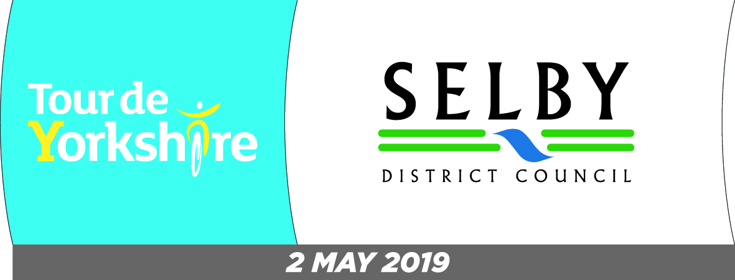
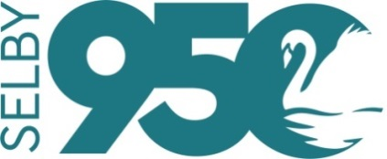
Sign up to the Tour de Yorkshire e-newsletter Allez Yorkshire on letour.yorkshire.com/email-updates
Follow us on Twitter: @selbydc, or like us on Facebook (just search for Selby District Council).
If you have a specific question you can call 01757 705101 or email info@selby.gov.uk.
Selby Abbey celebrates 950 years since its founding in 2019 and to celebrate, a series of events and activities will be taking place across Selby throughout the year. For more information, visit: www.selby.gov.uk/selby-950

